INSERT

The Insert statement is used to add one or more rows to a table. They can contain hard coded values or can use subqueries to retrieve data from other tables to insert.

Insert [into] table_name
[(column list)]
{Values
({DEFAULT | NULL | expression}, . . . )
|
Select}

Argument | Description
[into] | Is an optional keyword that makes the statement more readable
table_name | The name of the table that you are creating the new row(s) in
(column list) | Is a list of columns that will receive data. The column list must be comma delimited and enclosed in parenthesis. If the column list is omitted (VERY bad programming practice), SQL Server expects to receive data for all columns in the table and expects to receive the data in the order the columns were defined when the table was created.
Select | A valid select statement that returns row(s) of data to be loaded into the table.

Argument | Description
Values () | Introduces a list of data values to be inserted as the new row in the table. There must be one data value for each column in the column list (if specified) or in the table. The data values are comma delimited. The data values list must match the column list (if coded) or must match the order the columns were defined when the table was created. An individual data value can be:
  Data Value | Meaning
  An expression | A constant, variable or expression that defines the data value.
  DEFAULT | SQL uses the default value, as defined by the default constraint for the column
  NULL | SQL stores the null value in the column. The column must be defined to allow nulls when the table was created.

If an Insert statement supplies data that does not comply with the constraints defined for a column or supplies data that is incompatible with the data type of the column the Insert fails and an error message is issued by SQL Server.

In general there are three ways to do an insert:

- Select data from another table (e.g. a backup table).
- Hard code the data values in the INSERT statement itself.
- A combination of methods 1 and 2.

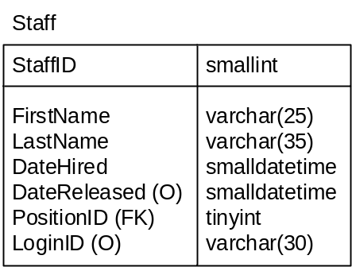

Given the staff table as defined above.

To add a new staff record with all columns provided:

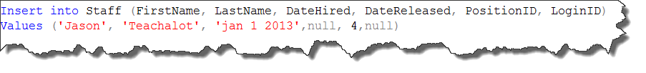

Note:
- The list of values is in the same order as the column list
- The StaffID column is not listed in the column list or provided a value. This is because StaffID uses the identity property and is populated by SQL when new record is inserted.
- The keyword null is used to insert a value of null in DateReleased and LoginID columns.

The same record could also be inserted as follows:

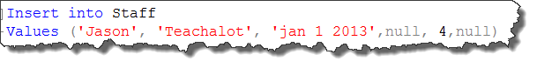
Note that:

- The values are supplied in the order that they appear in the table definition.
**This is not the recommended method and will not be considered acceptable in this course**

Sometimes data to be inserted is selected from the database. Data to be inserted can be provided by the user, selected from the database, or a combination of them both. This will be described in detail when we cover subqueries.

This insert statement would insert a new record for Jason Teachalot and assign him the same PositionID as Robert Smith.

It is important to remember that the subquery must only return 1 value to be used in the insert statement. If the subquery returns more than one value an error will occur.

Subquery returned more than 1 value. This is not permitted when the subquery follows =, !=, <, <= , >, >= or when the subquery is used as an expression.
The statement has been terminated.

If a column is defined with a default constraint the default can be used in the insert with the keyword default OR the column name can be ommitted from the column list and no value provided for the column.

OR

